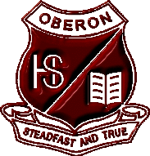

Oberon High School
School Refund Policy
In general, a refund will only be granted where:
• The activity is cancelled
• An incorrect payment has been made by student or parent/carer
• The student meets with serious misadventure
• The place of the student will be taken by another student

In every case, the refund will be limited to that amount not required for:
• Buses
• Money which cannot be refunded – e.g. pre-paid entry

Where the principal determines that a student will not participate in the activity a full refund will be given. Refunds can only be made by cheque payable to the parent/carer.

Oberon High School
Ross Street
Oberon NSW 2787
Ph: 02 6336 1606
Fax: 02 6336 2164
Email: oberon-h.school@det.nsw.edu.au

